WORKING TIME AND COST ESTIMATION AT WEST PORT JOHOR.

Scope of Work
1. Multibeam Survey
2. SingleBeam Survey at 6 rives
3. 3 Units ADCP

1. MULTIBEAM LINE SURVEY PLANING AND COSTING

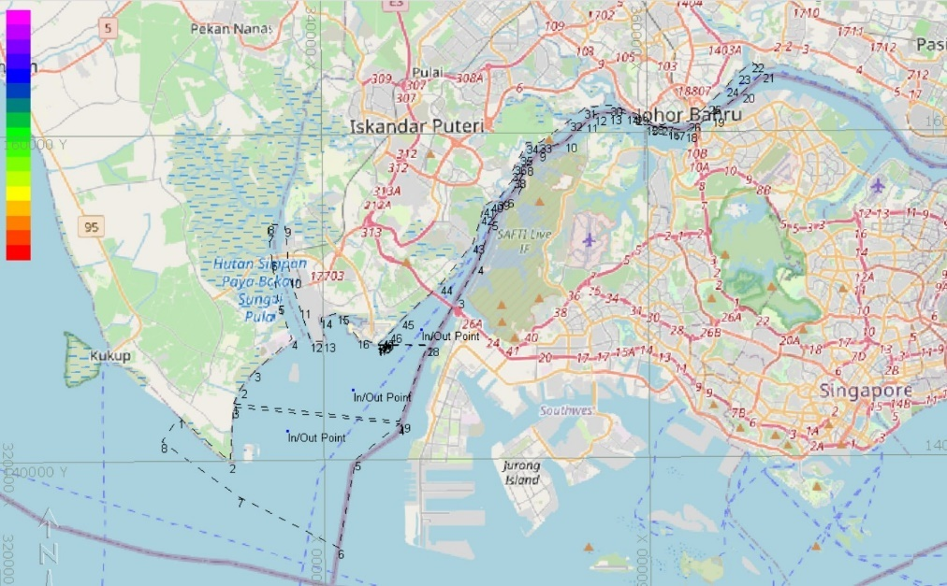
1.1 SITE SURVEY

LINE SURVEY INFORMATION
ESTIMATE DEPTH RANGE: 25M
SWATH ANGLE: 90^{O}
OVERLAP: 20%
LINE SPACING = 45M

1.2 LINE SURVEY BORDER A

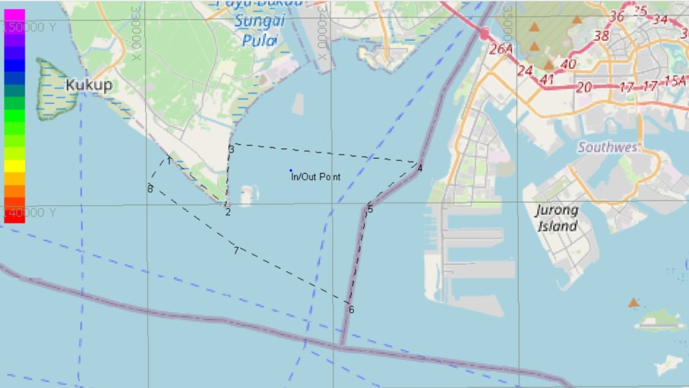

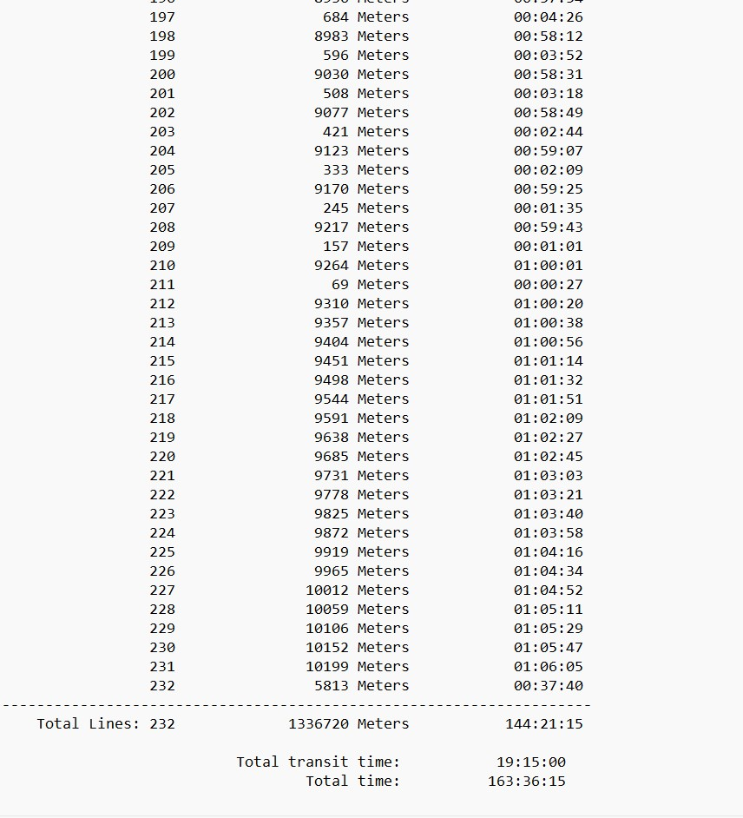
LINE SPACING = 45M
TOTAL LINE= 232 LINE

TOTAL TIME SURVEY= 163HOURS
TOTAL TIME /8 HOURS = 20.3DAYS

1.3 LINE SURVEY BORDER B
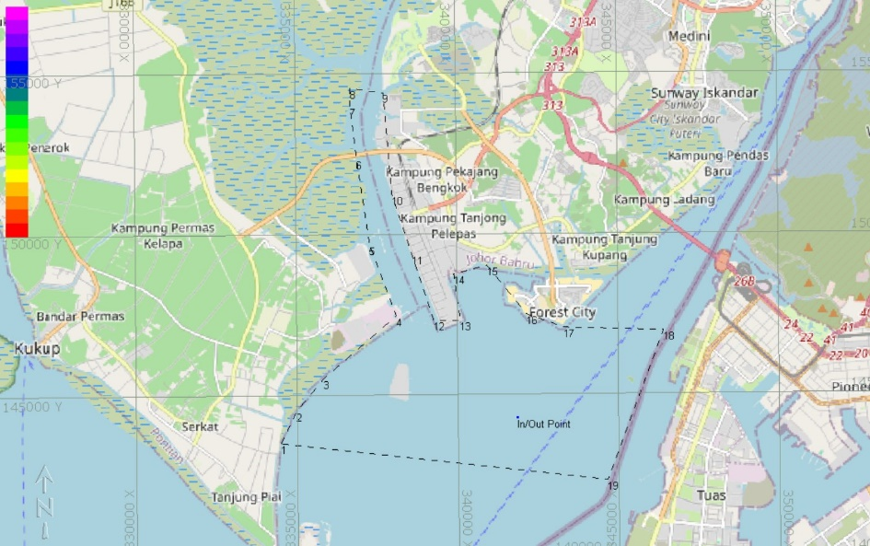

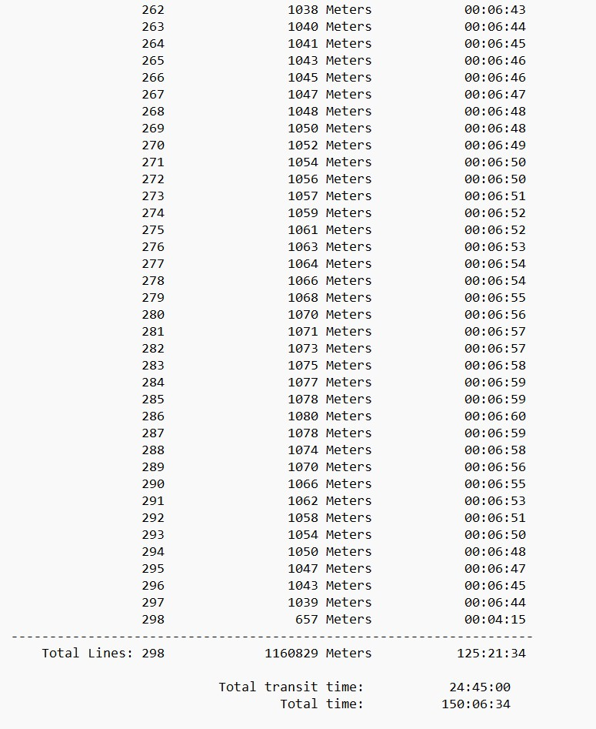
LINE SPACING = 45M
TOTAL LINE= 298 LINE

TOTAL TIME SURVEY= 150 HOURS
TOTAL TIME /8 HOURS = 18.75DAYS

1.4 LINE SURVEY BORDER C
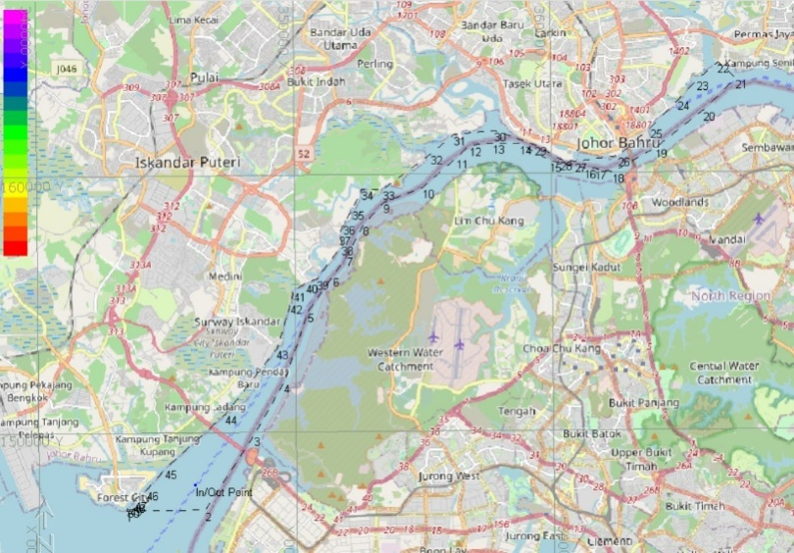

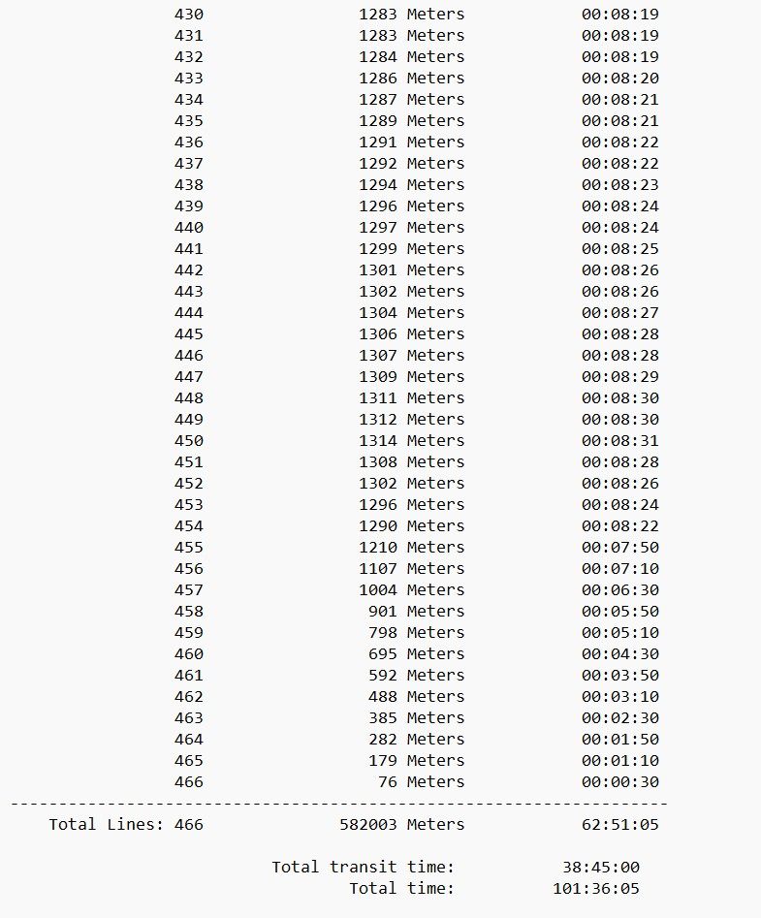
LINE SPACING = 45M
TOTAL LINE= 466 LINE

TOTAL TIME SURVEY = 101 HOURS
TOTAL TIME /8 HOURS = 12.62 DAYS

1.5 CROSS LINE

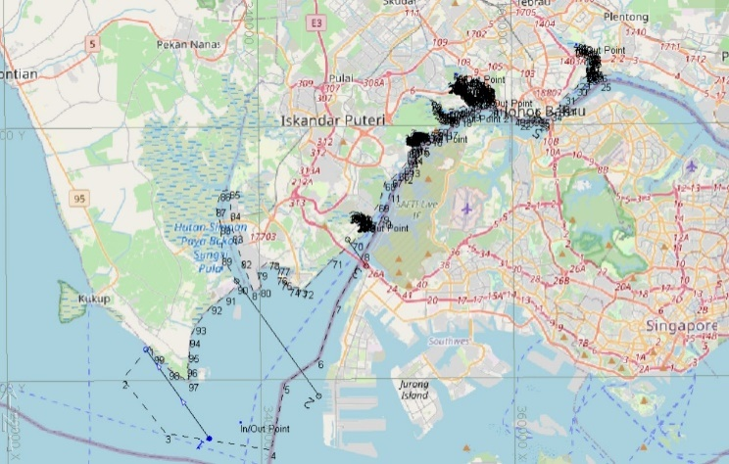
LINE SPACING = 9000M
TOTAL LINE= 5 LINE
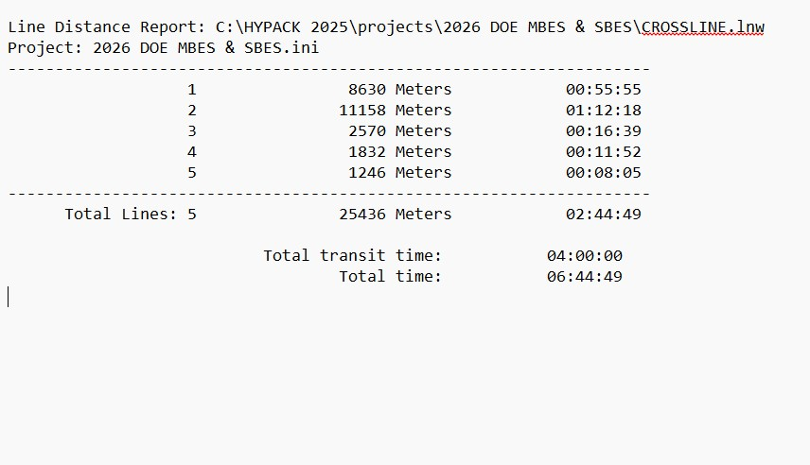
TOTAL TIME SURVEY= 6 HOURS 44 MINUTE

TOTAL WORKING HOURS
- BORDER A = 20.3 DAYS
- BORDER B = 18.75 DAYS
- BORDER C = 12.62 DAYS
TOTAL:51.675
- CROSS LINE = 1 DAY

TOTAL WORKING HOURS =52 DAYS
TOTAL ESTIMATE SURVEY WORK FOR MBES
Survey Work : 52 Days
Patch Test : 6 Days
Weather Standby: 6 Days
TOTAL SURVEY DAYS = 64 DAYS

Item | Description | Day | Qtty | Persons | Per day (RM) | Price (RM)
1 | Mod and Demod | 60 | 1 |  | Lump Sum | 30,000
2 | Multibeam Rental Packages | 60 | 1 |  | Lump Sum | 70,000
 | 2.1 Norbit Multibeam System
 | 2.2 Positining System
 | 2.3 Motion Sensor
 | 2.4 Qimara/ Qinsys
3 | Boat Rental | 64 | 1 |  | 3000 | 192000
4 | Tide Gauge Rental | 64 | 3 |  | 200 | 38400
5 | Leveling Work |  |  |  | Lump Sum | 5000
6 | Insurance |  |  |  |  | 5000
7 | Personal | 64 |  | 4 | 400 | 102400
8 | Surveyor On Board | 6 |  | 1 | 1200 | 7200
9 | Miscellaneous (Lump Sum) |  |  |  |  | 15,000
10 | Analysis, Processing , Filtration |  |  |  |  | 10,000
11 | Endorsement from PhN and Land Surveyor |  |  |  |  | 6000
12 | Report |  |  |  |  | 10,000
 | TOTAL ( RM) |  |  |  |  | 491,000

2.0 COST FOR MBES SURVEY FOR WEST JOHOR

2. SINGLEBEAM LINE SURVEY PLANING AND COSTING

2.1 Focus on six (6) main rivers and coverage:
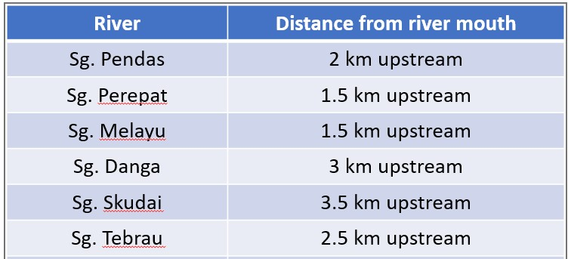
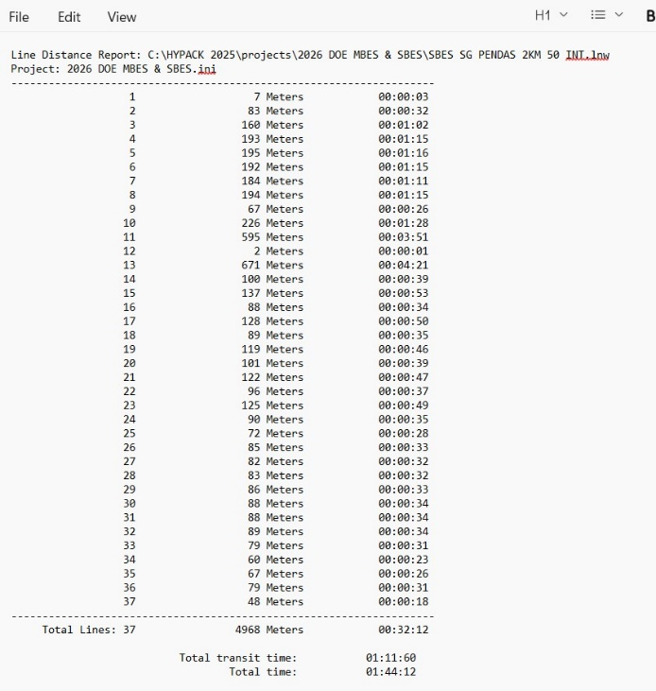
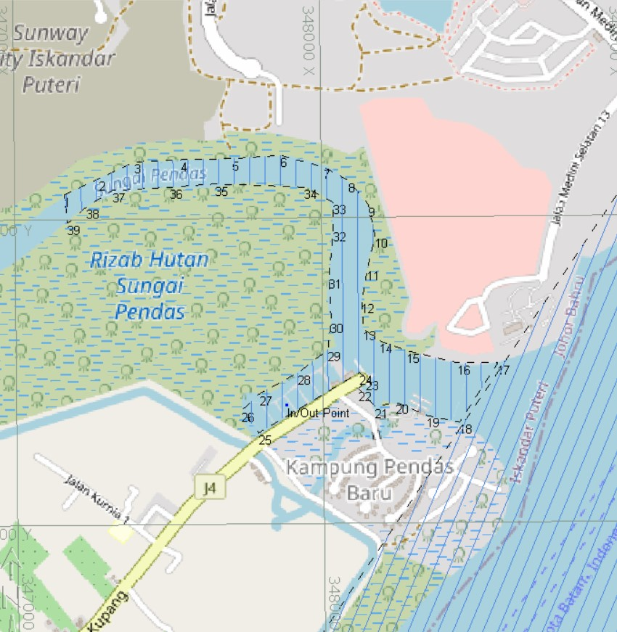
- Sungai Pendas

Line interval :50 mtr
Total line :37 line
Required time :Apprx : 2 hours

- Sungai Perepat
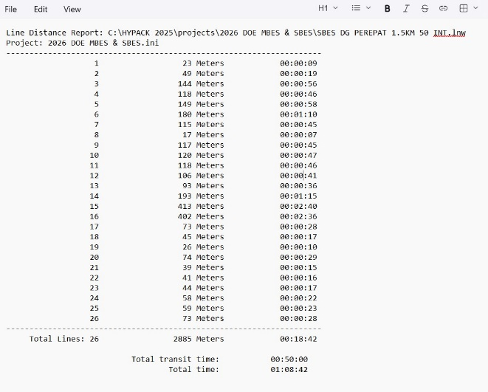
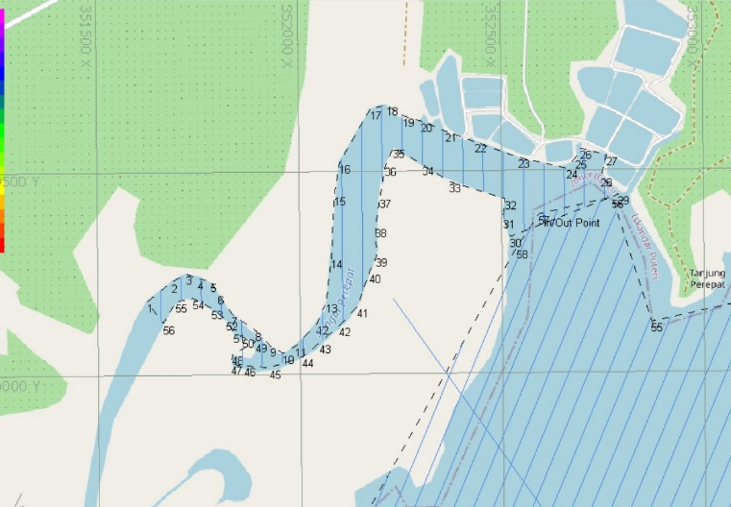

Line interval :50 mtr
Total line :26 line
Required time :Apprx : 1 hours

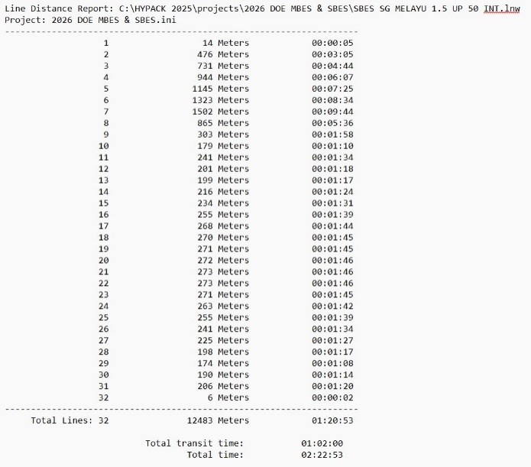
- Sungai Melayu
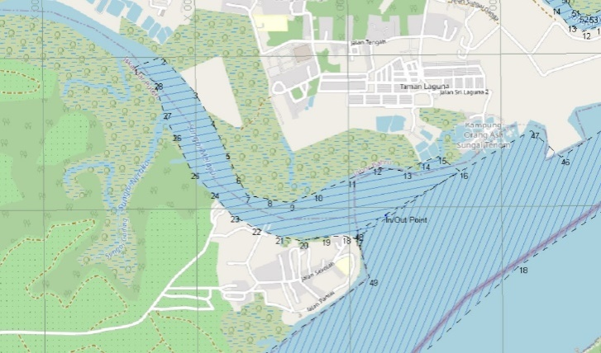

Line interval :50 mtr
Total line : 32 line
Required time :Apprx : 2 hours 30 minutes

- Sungai Danga
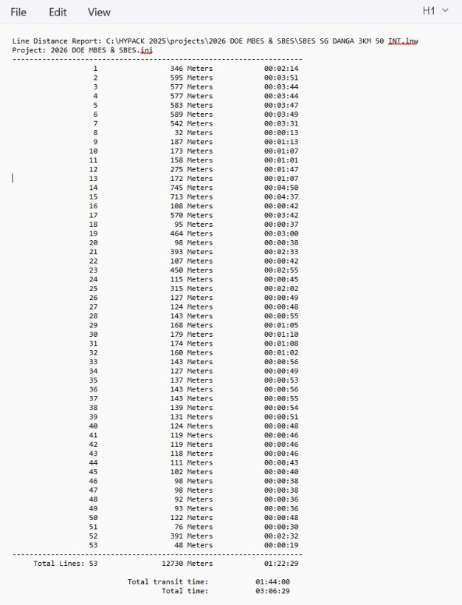
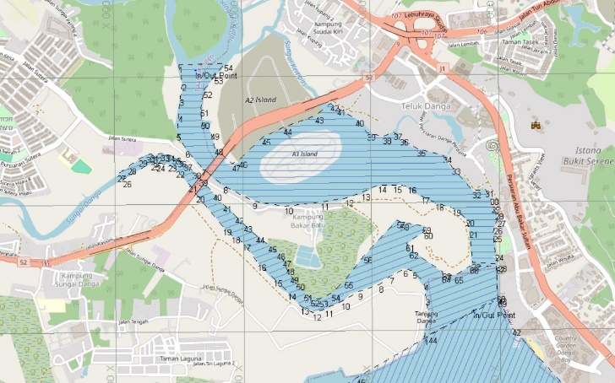

Line interval :50 mtr
Total line :53 line
Required time :Apprx : 3 hours

- Sungai Skudai
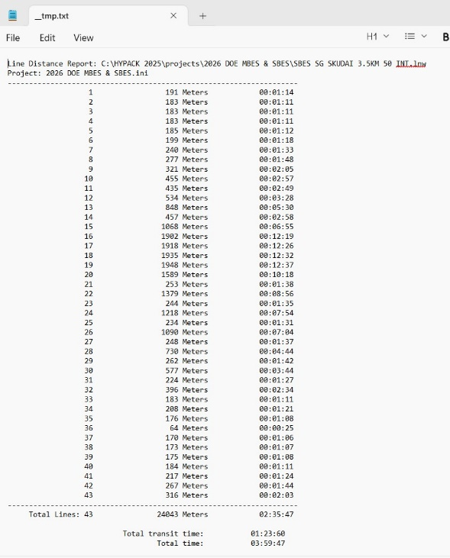


Line interval :50 mtr
Total line : 43 line
Required time :Apprx : 4 hours

- Sungai Tebrau
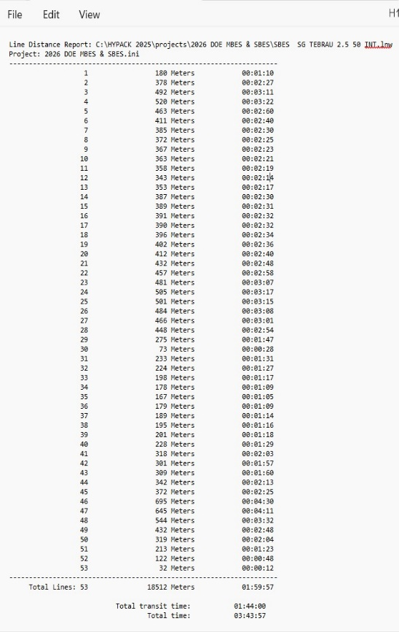
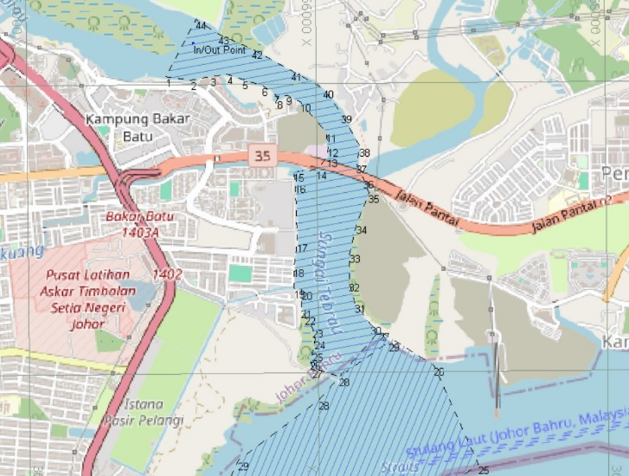

Line interval :50 mtr
Total line : 53 line
Required time :Apprx : 4 hours

6. TOTAL ESTIMATE SURVEY WORK FOR MBES

Survey Work : 6 Days
Weather Standby: 2 Days
Mod Demod : 3 days
TOTAL SURVEY DAYS = 11 DAYS

7.0 Cost SBES for 6 rives
Item | Description | Day | Qtty | Persons | Per day (RM) | Price (RM)
1 | Mod and Demod | 11 |  |  | Lump Sum | 12,000
2 | Single Beam Rental Packages | 11 |  |  | 1200 | 13200
 | 2.1 Norbit Multibeam System
 | 2.2 Positining System
3 | Boat Rental | 11 | 1 |  | 3000 | 33000
4 | Tide Gauge and levelling work |  |  |  | Lump Sum | 6000
6 | Insurance |  |  |  |  | 5000
7 | Personal | 11 |  | 4 | 350 | 15400
8 | Consumable Item |  |  |  |  | 4000
9 | Anaysis, Processing |  |  |  |  | 5000
10 | Report |  |  |  |  | 5000
12 | Endosment from PhN and Land Surveyor |  |  |  |  | 5000
 |  |  |  |  |  | 103,600

3.0 ADCP WORK and Coasting
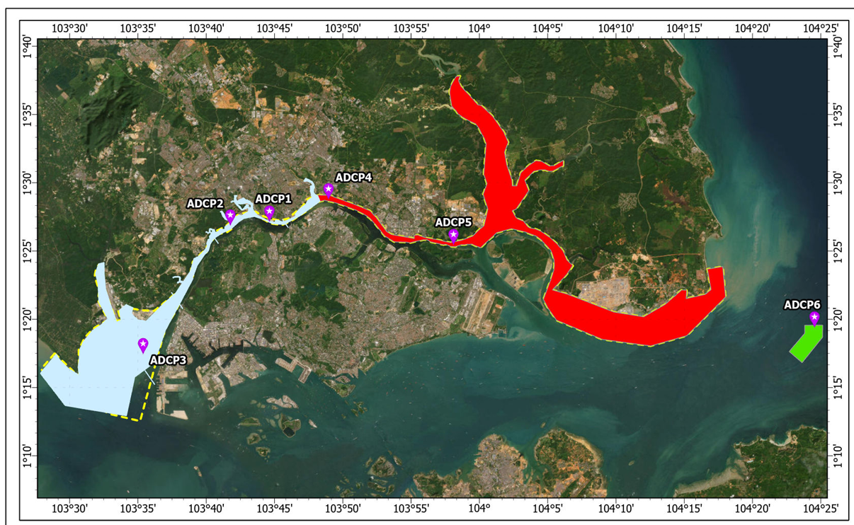
Item | Description | Day | Qtty | Persons | Per day (RM) | Price (RM)
1 | Mod and Demod | 15 |  |  | Lump Sum | 15,000
2 | ADCP Rental for (15 days) Packages | 15 | 3 |  | 600 | 27000
 | 2.2 Battery |  | 3 |  | 1500 | 4500
3 | Boat Rental | 12 | 1 |  | 3000 | 36000
4 | Insurance ADCP |  |  |  | Lump Sum | 10,000
5 | Personal | 15 |  | 6 | 350 | 31500
6 | Consumable Item |  |  |  | Lump Sum | 5000
8 | Anaysis, Processing |  |  |  |  | 5000
9 | Report |  |  |  |  | 5000
 |  |  |  |  |  | 139,000

Cost ADCP

